**Virtual Service**

<https://istio.io/latest/docs/reference/config/networking/virtual-service/>

Communication between software components in an application 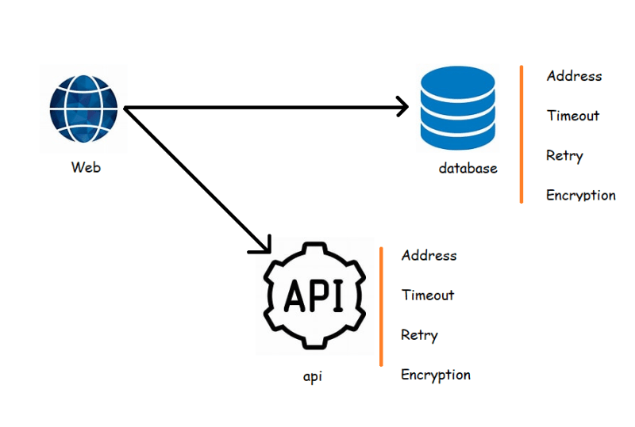

Service to service communication by ISTIO

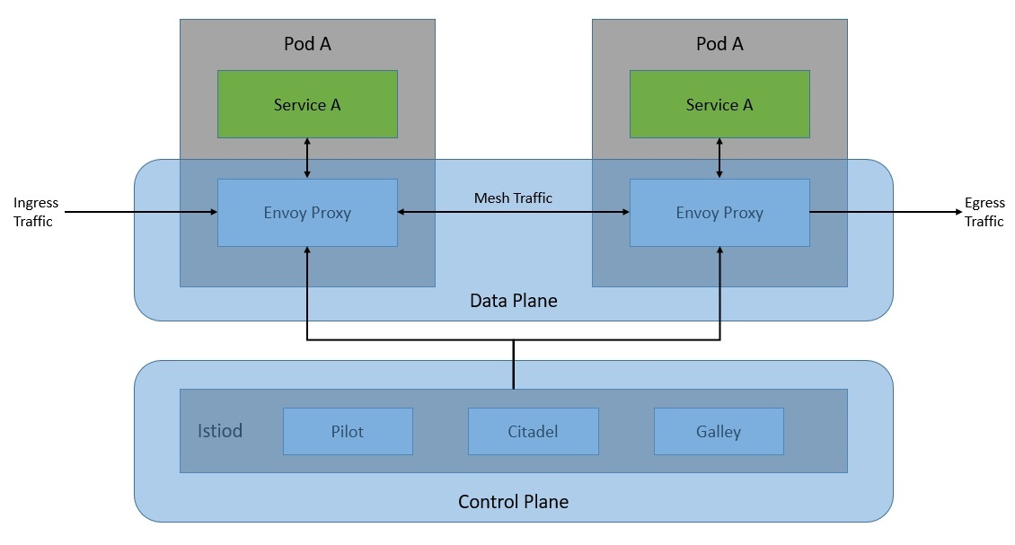

Microservice demo application architecture 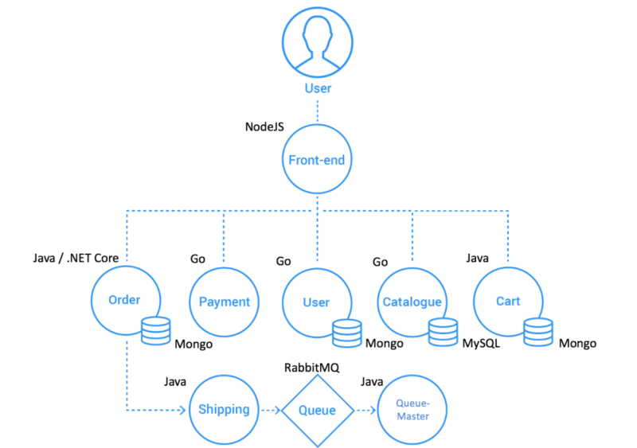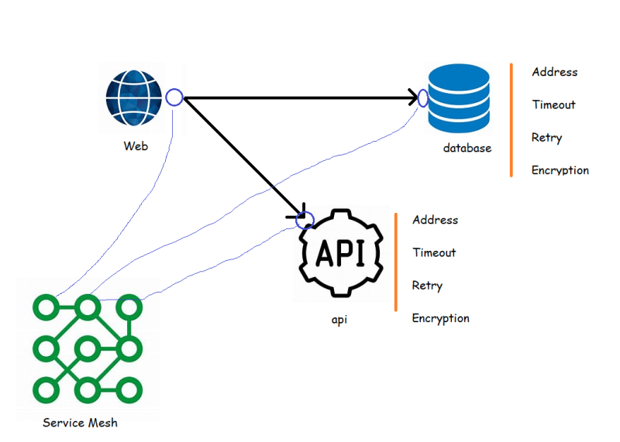

The changeset for details service <https://github.com/asquarezone/ExpertKubernetes/commit/f5cf65f8a2a1316e25ad6b576ab0ce6917dee4b5> and apply this 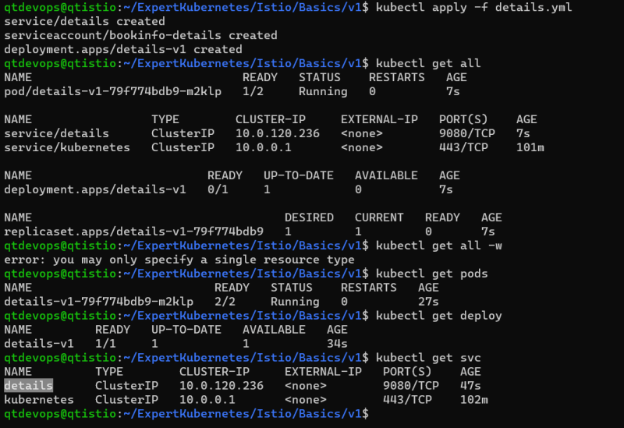

Add ratings service changeset <https://github.com/asquarezone/ExpertKubernetes/commit/40ec099b26f747a88296a766bbecb9781f9ba8e3> and apply these changes 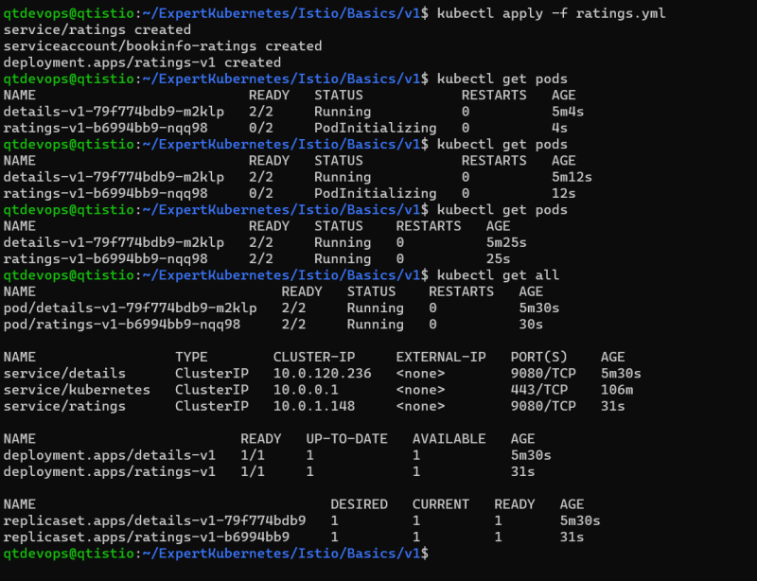

Created a review application with only v1. <https://github.com/asquarezone/ExpertKubernetes/commit/ec79e917835cfbbfce04308b63126486aa154158> for the changes and apply the changes 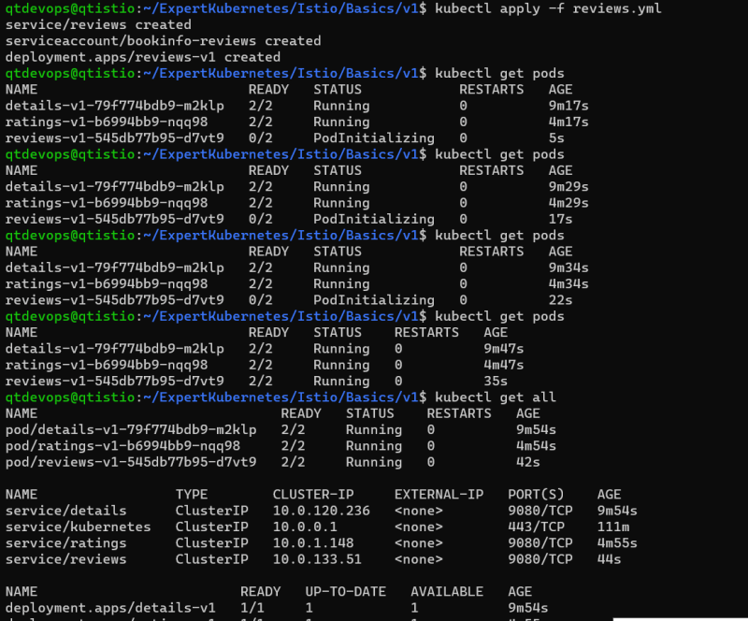

<https://github.com/asquarezone/ExpertKubernetes/commit/d418459ea5705e1681e78e328765370524bd79e1> for the product page changes and apply the product page 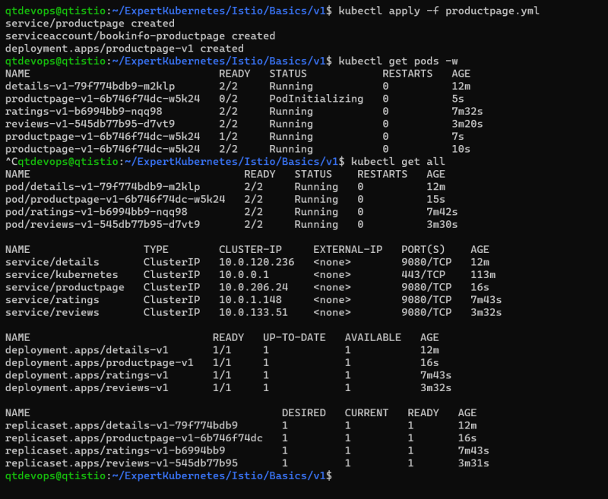

Now lets try to observe any pod 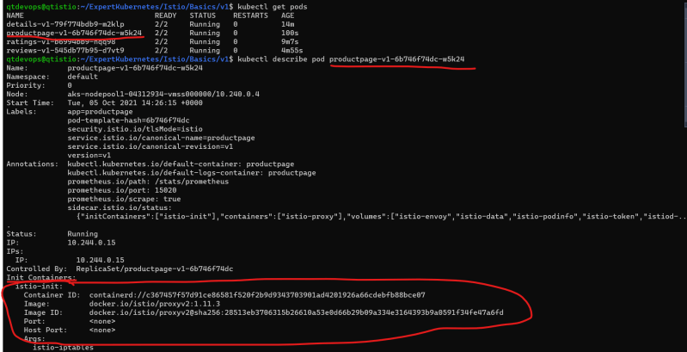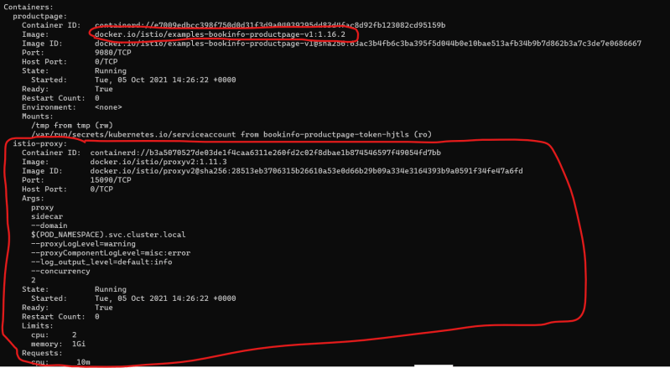

* The envoy proxy is automatically injected into the pod, this is because while we were setting up istio we have executed the following command, which enables automatic istio injection in default namespace

kubectl label namespace default istio-injection=enabled

* We need to access the application from outside k8s cluster, for this we would be using the gateway
* Add the gateway for external access <https://github.com/asquarezone/ExpertKubernetes/commit/49657328d08ca358fe2c59e2da06b9888bc2e99b> for the changeset.

In the above changeset we have custom resources defined by istio, lets apply the changes 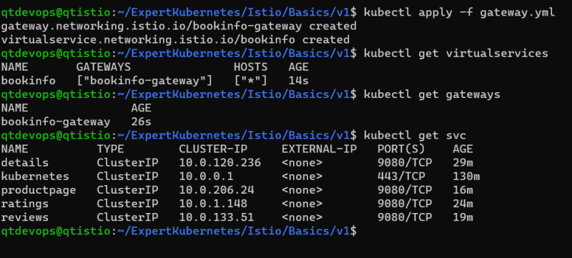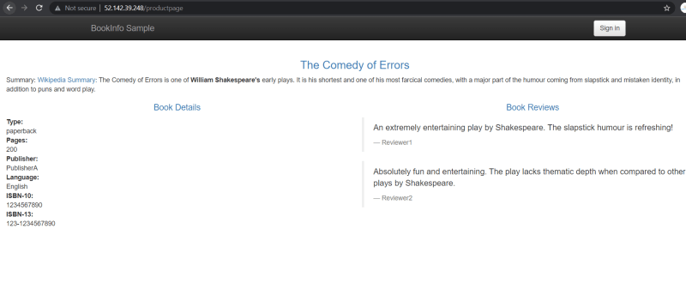

Now lets delete the details service and try to use the products page 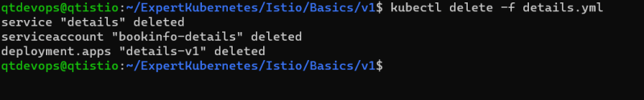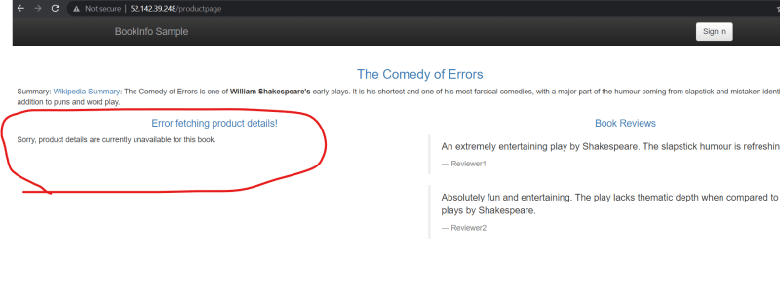

Lets create a virtual service for details with retries <https://github.com/asquarezone/ExpertKubernetes/commit/28d970175b9cb4326e5e488f067fce5106e37ab2> for the changes 